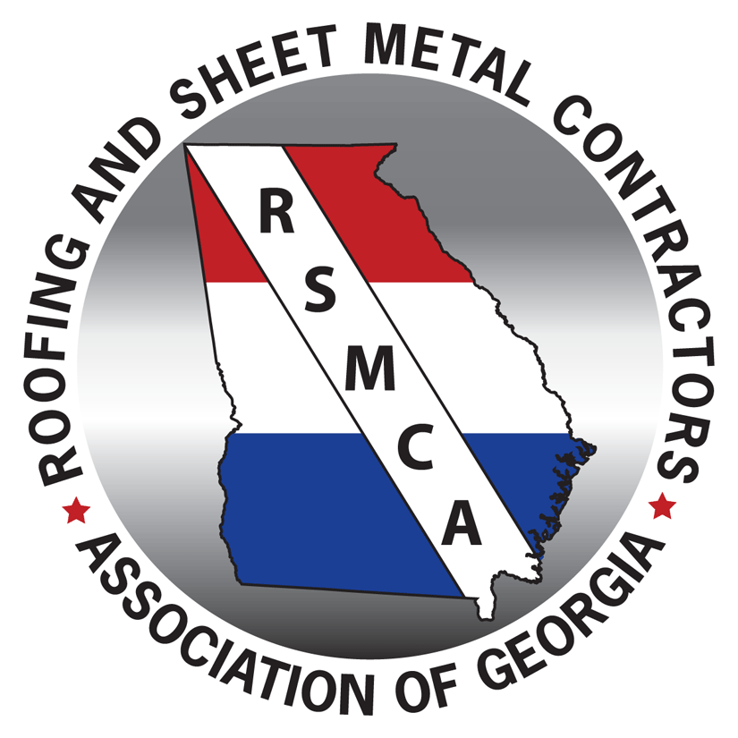
2017 RSMCA Convention Agenda
July 20th – 22nd
King and Prince Beach & Golf Resort
St. Simons Island, GA
Thursday – July 20
1:00 p.m. - 5:00 p.m. | Registration – Lobby foyer
3:00 p.m. - 5:00 p.m. | Board Meeting – Solarium
5:30 p.m. - 6:30 p.m. | Welcome Reception – Retreat
 | Open Night for Dinner
Friday – July 21
7:00 a.m. - 7:30 a.m. | Breakfast Buffet– Lanier Ballroom
7:30 a.m. - 7:45 a.m. | Welcome: Mark Jenkins, RSMCA President
7:45 a.m. - 8:30 a.m. | NRCA State of the Industry: Reid Ribble, NRCA CEO
8:30 a.m. – 9:15 a.m. | EPS Insulation: Nick Harvill, ACH Foam Technologies
9:15 a.m. – 9:30 a.m. | Break
9:30 a.m. - 10:00 a.m. | Technology Session: Eagle View, Mark Raines
10:00 a.m. - 10:30 a.m. | Technology Session: The Estimating Edge, John Lombardo
11:30 a.m. - 4:00 p.m. | Golf Tournament – King and Prince Golf Course
 | Shuttle to golf course leaves 10:45 a.m., box lunch provided for golfers
5:00 p.m. - 7:00 p.m. | President’s Reception – Solarium
 | Open Night for Dinner
Saturday – July 22
8:00 a.m. - 8:30 a.m. | Breakfast Buffet – Lanier Ballroom
8:30 a.m. - 8:45 a.m. | Welcome: Jonathan Glisson, RSMCA Vice President
8:45 a.m. – 9:45 a.m. | New Research on Slip/Fall Prevention  Gary Clevenger, CNA Insurance  Employee Perception Surveys – What’s the Value?  Bob Cauthen, CNA Insurance
9:45 a.m. - 10:45 a.m. | Performance Management: Driving Greater Efficiency Through Quality  Brad Humphrey, Pinnacle Development Group
10:45 a.m. - 11:00 a.m. | Break
11:00 a.m. - 12:00 p.m. | Falling Back in Love with Your Business (spouses encouraged to attend): Brad Humphrey, Pinnacle Development Group
12:00 p.m. | Closing
 | Open Day for Resort Enjoyment / Kids’ Beach Activities 1:00 p.m. – 3:00 p.m.
6:30 p.m. - 7:00 p.m.  7:00 p.m. - 8:00 p.m.  8:00 p.m. - 11:00 p.m.  6:30 p.m. - 11:00 p.m. | Cocktail Reception – Lobby foyer / Lanier Ballroom  Awards Dinner – Delegal  Silent Auction & Entertainment – Lanier Ballroom  Kids’ Activity/Childcare – Retreat

